1. Introduction

Our client, a church in Wichita Falls is interested in improving its financial records software by adding some functionalities and features to the existing software. The current software in use does not have a good user interface. It also does not generate good reports as required by the secretary and the donors. The new software system must have a good user interface and be able to generate the required reports. It should also a good user interface.

  - Purpose of Plan

This document details the Project Plan for the Church Financial Management Software, which Software Engineering Group III (also referred to as MI4) has devised to assist in the software development process. The plan outlines the different areas of the project that must be addressed for the successful development of the software. It establishes guidelines for resources that will be used in the project, and also points out additional resources that might be needed. The Project Plan also shows how the software development team is comprised and states the means of reporting. It further addresses some of the risks involved in the project and ways of managing the risk, if they occur. Also, quality assurance will be mentioned, and a glossary of terms used in this document is included.

1.2. Project Scope and Objectives.

The client, a church in Wichita Falls wants to improve the financial management software it is currently using to manage day to day financial activities of the church. The client has software already in place for this purpose. However, the software in use is not user does not have a user friendly interface and does not have the capability of generating extensive financial reports as required. Financial reporting is an important activity of the church, making the ability of an application to generate reports an important feature of financial management software. Hence, the client is seeking to upgrade the current software in order to achieve its goal of proper financial reporting.

1.2.1 Statement of Scope

The Software Engineering Group III has been contracted by Ms. Wuthrich, who is the church secretary and primary user of the system as well as a computer science instructor at MSU to develop the Church Financial Management Software. The client has already had meetings with the team (MI4) and provided a list stating the objectives and the expectations of the software to be developed.

The client has stated that reporting is the main issue with the current software in use and therefore specified that the new software must provide the church with an extensive reporting functionality, which is one of the main reasons for the upgrade as the present system does not generate good reports as expected. The team is also responsible for determining what other reports the new software can generate in addition to the required ones. However, any additional reports will first be verified with the client. This project is estimated to be completed by the end of the spring semester.
1.2.2 Major Functions

The main function of the new system is to replace the existing system because the system being used has weaknesses especially in generating reports. It is also not user friendly hence a new graphical user interface is needed to make it user friendly. The new system should make it easier for the secretary to keep track of donations made to the church. She should be able to capture and store the various types of donations into the database of the software. Details of the donors should also be stored in the database, with each donor assigned a unique envelope number.

The software should provide a good Graphical User Interface (GUI) to enable the user to create new records of donors, edit existing records and also delete and update records with ease. The application should also allow the user to search members based on envelope numbers. Also, software should automatically retrieve details of members from the database.

In addition to these requirements, the system should generate weekly, monthly and yearly reports of all donations made to the church whenever needed by the secretary or the donors. These reports can be printed and given to donors for their own perusal or for tax purposes.

1.3. Overview

Section 2 describes the Project Organization. It covers the following; process model, team structure, communication, and reporting. It also gives details about project resources, such as people, hardware and software and provides information regarding the risk management, strategies to handle the various risks that might be faced. Finally, tracking and control mechanisms are also mentioned and described in this section.

2. Project Organization

A project organization is a structure that facilitates the coordination and implementation of project activities according to the some process model and guidelines. Its main reason is to create an environment that fosters interactions among the team members with a minimum amount of disruptions, overlaps, and conflict. The group MI4 has been assigned to work on the Church Financial Management Software. The group has organized itself in such a manner as to help bring focus to the different parts of the project in order to achieve our goal of delivering quality software in time and within budget.

2.1 Process Model

The Waterfall process model, shown in figure 1 is chosen to develop this application. It is also referred to as a linear-sequential life cycle model. The main reason for choosing the Waterfall process model is because it is simple to understand and use. In Waterfall model, each phase must be completed fully before the next phase can begin. Basically, we are using the Waterfall model for this project because the project is small and there are no uncertain requirements as two prototypes were developed last semester and have been outlined by client to give feedback on critical requirements to give us a clear final requirement. At the end of each phase, a feedback will be sought from our client, Ms.Wuthrich and the instructor, Dr. Stringfellow. It will be easy to determine if the project is on the right path, since the user will evaluate the user interface design and for the instructor to give feedback on the software architecture design. So, each phase has specific deliverables and a review process.

There will be very little customer interaction during the development of the project, except in the early stages when we’ll be gathering requirements specifications from our client. The project will only be shown to the client once it’s complete and ready to be implemented.

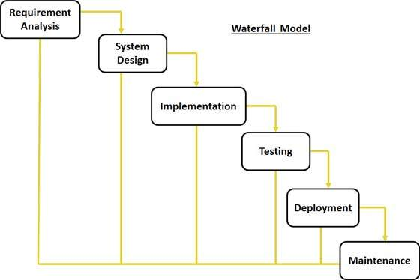

Figure 1. Waterfall Model [ 1].

2.2 Team Structure

The team will use a controlled decentralized structure. The team has chosen Mr. Ramesh Mannava as its team leader. The team leader’s duty will be to assign tasks to members of the team and to ensure that team meetings remain focused and stick to the agenda. The group will meet each Tuesday and Thursday, in class at an assigned time and any other time and day whenever necessary. The team leader will call the meetings and set the agenda for the meeting. Each team member should be aware of the set agenda and should come to the meeting well prepared.

  - Communication

All communication with regards to the project shall be done using a WhatsApp group created by the team leader and email. This will ensure the team members are in constant touch with each other. We shall have weekly meetings to check on the status of the project and track milestones.

2.4 Management Reporting

The team will document meeting discussions and post the minutes prior to the next meeting. Team members will report progress to the group via email and at group meetings. The team should follow the agenda set forth for the meetings, as previously disseminated via email. The minutes and other created documentation should be collected, organized and maintained by the scribe. The group is also required to send reports to the client indicating the progress of the project and to show that members are all participating equally in the group. Any issues that will arise which the team leader cannot solve shall be taken to Dr. Stringfellow for guidance and possible solution.

3. Project Resources

The software project which the group MI4 has committed itself requires several resources. Such resources include personnel, hardware, and software needs. Beyond personnel, the client is responsible for the provision of the necessary tools for the timely completion of the project.

3.1. People

MI4 consists of four members, each having different task to perform. Team members have committed themselves to this project until its completion. The members are also responsible for participating in the development of the project, and must, to the best of their abilities, play an equal role in the development of the Church Financial Management Software. Team members are not restricted to the following roles only. Each member shall perform other duties as well if need be. The members are:-
- Ramesh Mannava- Team Leader & Lead Programmer
- Clive Matiku- Project Documentation
- Divya Shree- Interface Design
- Majesh Salla- Database Design

3.2 Hardware and Software

This project will require both hardware and software in order to be implemented. The team must also have knowledge of the hardware and software being used. If the team or a team member does not have working knowledge of the resource being used, it is their responsibility to learn that new resource in a timely fashion.

Hardware: Minimum requirements

Processor : Dual core
Memory Ram : 1 GB
Hard Disk : 40 GB

Software: System software requirements to run the application

Development: Eclipse
Database: MySQL.
Operating System: Windows 7/8/8.1/10
Web browser: Internet explorer, Chrome, Mozilla
4. Risk Management

The Church Financial Management software development process like any other kind of project involves several risks. It is important that such risks be analyzed and appropriate method of correction put in place to minimize the impact of the risks. Project risks include management change, requirements alterations, team member dropping out of class and changes in the specifications, team member falling sick among others.

4.1 Likely Risks

As mentioned in the previous section, in the process of the system development, team MI4 is likely to encounter risks of several kinds. The team leader together with the team members must devise plans to overcome each risk. Table 1 shows some of the potential risks, impacts and strategies to deal with them.

Table1.shows possible risks and ways to manage
Risk | Chance | Impact | Strategy
Sickness of team member | Low | Tolerable | Redistribute work  And reschedule members work
Delay | Very Low | Serious | Successive meeting  for monitoring project progress
Requirement Changes | Medium | Medium | Extra effort needed from all team members
Compatibility Constraints | Low | Serious | Additional Research
Lack of learning | High | Serious | Learn and practice concepts
Lack of resources(time, human resource, materialistic resource ) | High | Serious | Preplan and acquire the resources

4.2 Risks Management Plan

The team has identified risks and has a plan to minimize the effects of each risk encountered in the project design and development. This plan is described in figure 2 of the project plan.

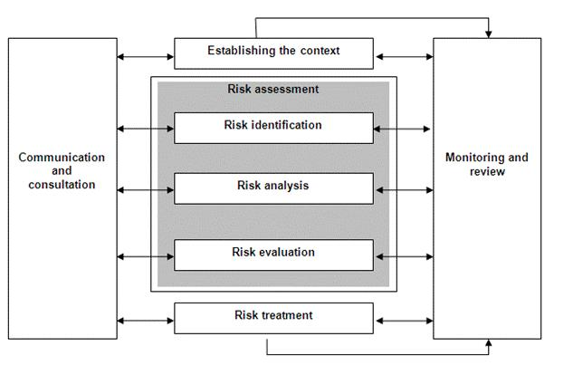
Figure2. Risk Management Plan [1].

4.3 Risk Monitoring

The team will closely monitor the development of the project with the intention of avoiding the needless occurrences of identified risks. The team will also seek to effectively address risks whenever they arise. All members are held accountable for the monitoring of the risks in the project. This is done especially because all risks greatly affect the timely deployment of the project.

5. Schedule

The schedule for the project will outline required time for each task to be completed and the individual milestones that the group needs to reach.

5.1 Task List and Resource Allocation

The following diagram helps us utilize the available resources by scheduling the team members. It helps optimize time spent on the project by the team members. Figure 3 shows the various tasks assigned to each member and available resources for the task.
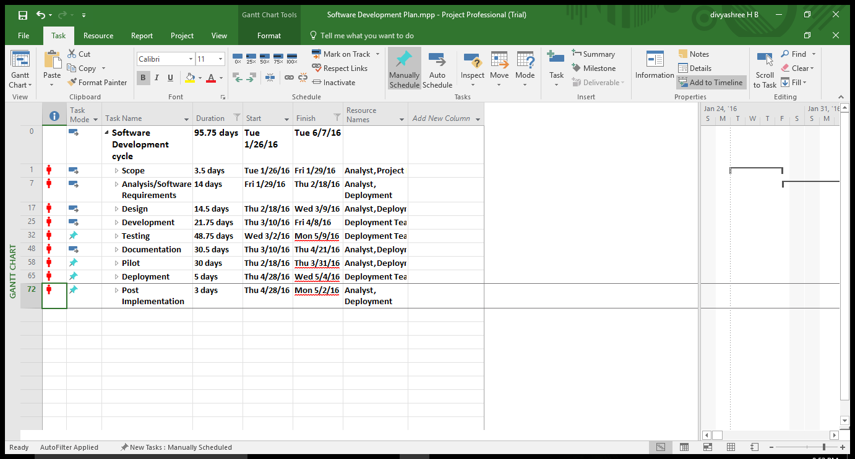
Figure3. Microsoft Project - Schedule

5.2 Timeline

Figure 4 shows the timeline for the project activities to be completed.

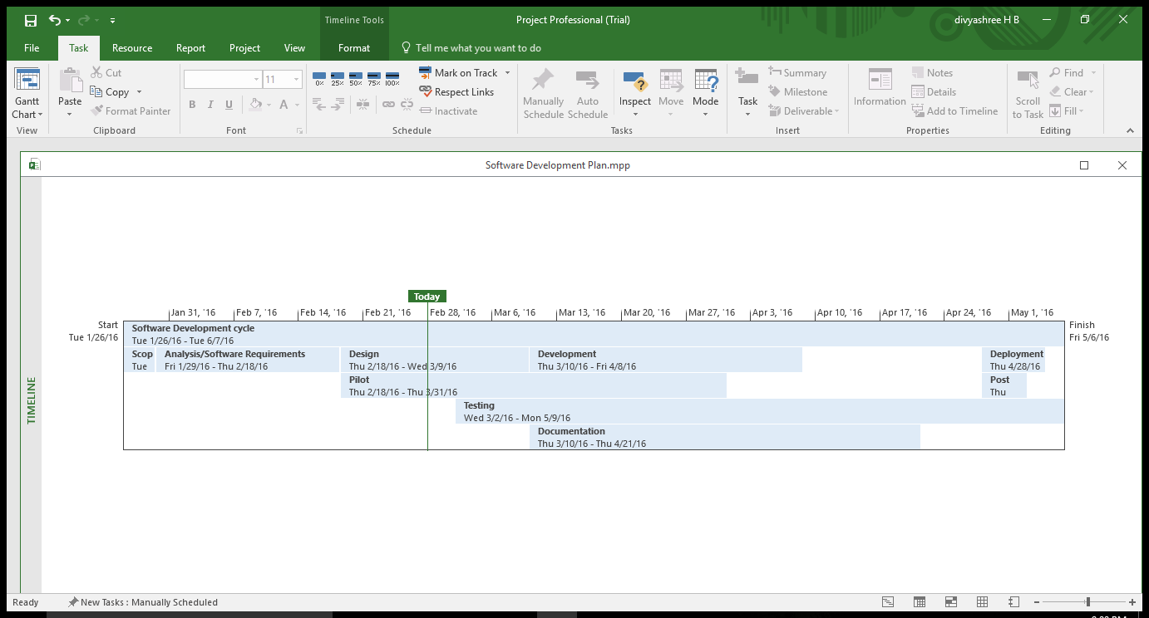
Figure4.GANTT Chart of the scheduled.

5.3 Task Network Diagram

Figure 5 shows the task network diagram. It shows the required sequence of events and activities for the completion of the project.
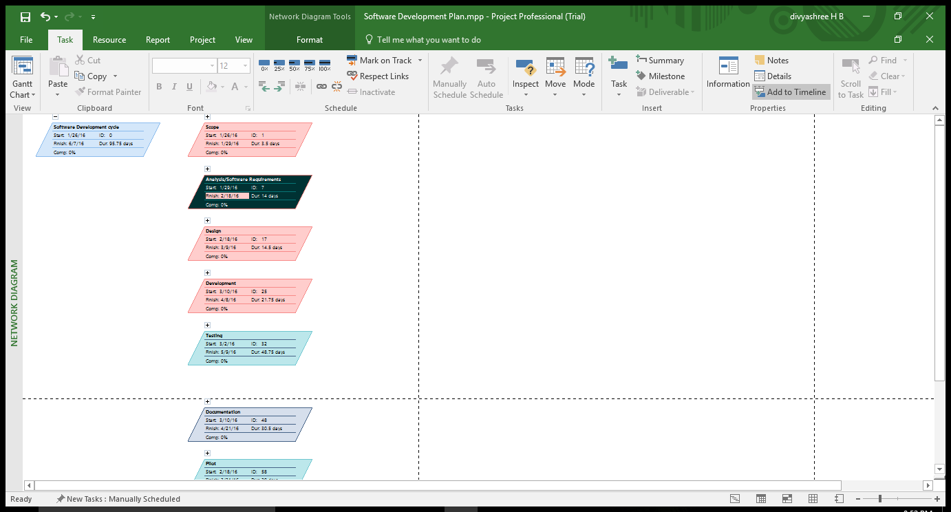
Figure5.Network Task Diagram from MS project.

5.4 Objective Grading Sheet

Figure 6 shows the objective grading sheet used to grade the team members on their contribution and performance towards completion of the project.

6. Tracking and Control Mechanics

The project will be monitored during the development process to catch any error that may arise. The group will develop a plan to test the software at various stages of the development. The group will also review the requirements and specifications plan to ensure no oversights.

The testing documentation will outline the process that the testers will follow to catch any possible error in the system. Testing will be documented and will state what the errors were and if there were not errors. Such a plan, carefully executed, would ensure the system is deployed with optimal accuracy.

6.1 File Tracking

In order to keep track of files and documents regarding project, the team plans to use GitHub. It is a web-based repository hosting service. GitHub offers source code management functionality and also provides features like access control and collaboration features such as bug tracking, feature requests, task management which is useful for project management.

7. Glossary

Client – The party for which services are rendered.
Database – The file containing the collection of data for the software.
MySQL Server – Database management software.
Microsoft® Project – Scheduling software from Microsoft Corporation.
Microsoft® Windows – A family of operating systems from Microsoft Corporation.
Waterfall Process Model – Framework for managing product development.
Requirements Document – An abstract system definition to help the client. understand what the software will do.
Specification Document – A detailed statement outlining the software’s functionality and constraints.
Team leader – Leader of the software development group.
Time line – Schedule detailing a chronological sequence of events.
Milestone – A significant event in the software development process, such as the completion of a major component.
Gantt Chart- A type of bar chart that illustrate a project schedule.
Controlled decentralized- Type of team organization where decisions are made by consensus and all work is considered group work.

8. References

[1]. Somerville, I., Software Engineering 9th edition book, NY, Pearson, 2011.
[2] Dr Stringfellow, Software Engineering class

